How to retrieve lost/missing video footage:

Locate files on SD Card/HDD
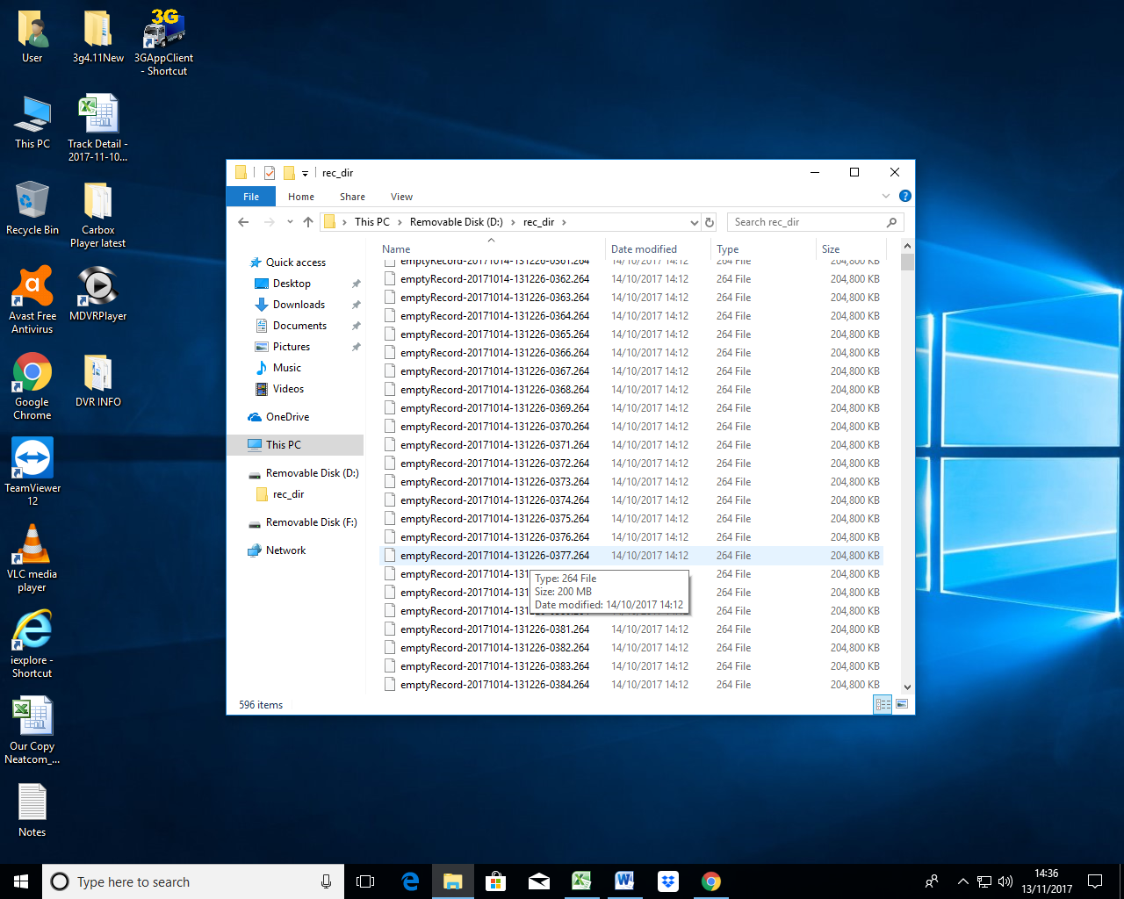
Rename a file by deleting “emptyRecord” and replace with “R” at the start of the file name, and insert the letters “P0F” at the end of the file name as per screenshot below:

R20171101-165127NMD25P0F.264
Once you have renamed the file you can view the video footage in MDVR player by opening the player and dragging the file into the player, once this is playing, time and date will be shown and then you can calculate which other files need to be renamed to access required missing video footage.
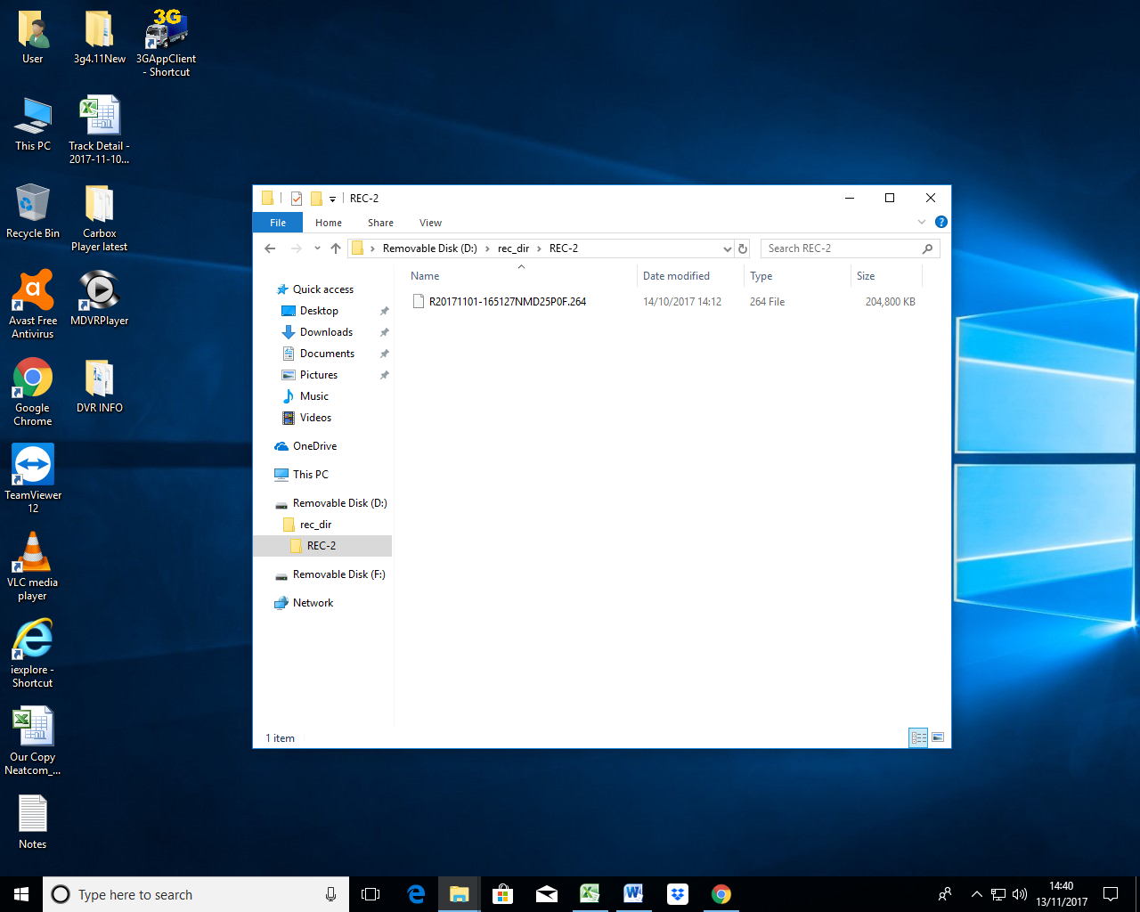

The below screenshot shows MDVR Player open and the file located in the SD/HDD renamed then dragged into the player to view the missing video footage.

