DVR settings 3G/APN/Device:
Log in to DVR (password: 000000)
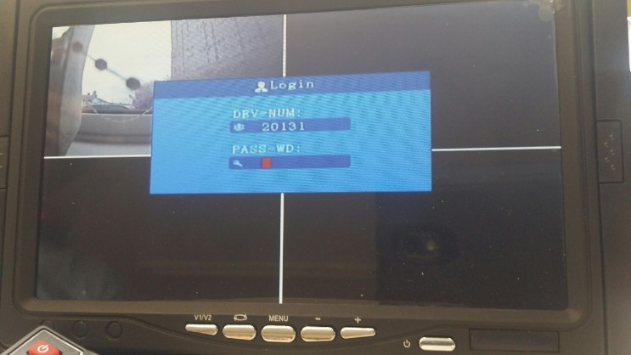
Scroll down to system setup (blue box) and input unit number (5 digits) into device id and phone number.
Device number and phone number should be the same like: 20002/20003 etc.
Then click SAVE.
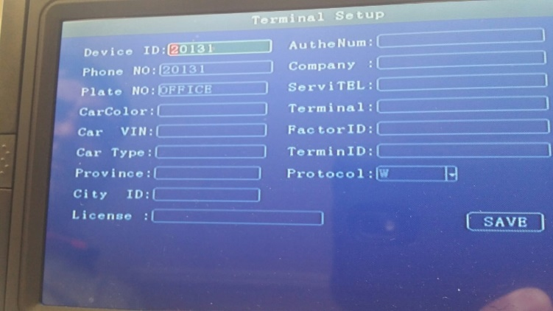
Scroll down to record setup and across to record (red box) set camera type to normal.
Then click SAVE.
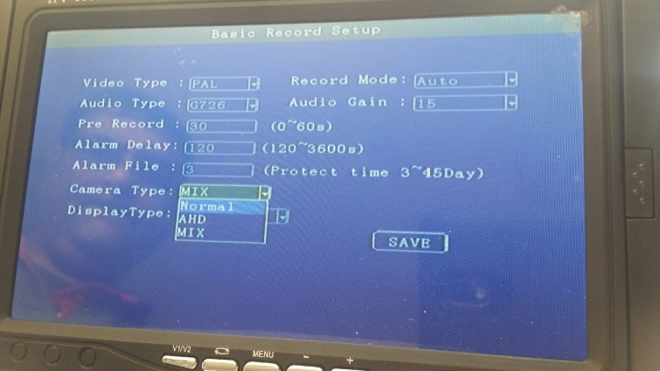

Main stream: This is to setup the code stream and definition of video channel and set at D1
Sub-stream is the code stream which device upload via 3G/4G. Set at CIF.

Go to network tab then centre
DVR settings: centre IP: 213.171.205.209 (server IP address)
Port number: leave as default (6608)
Then click SAVE.
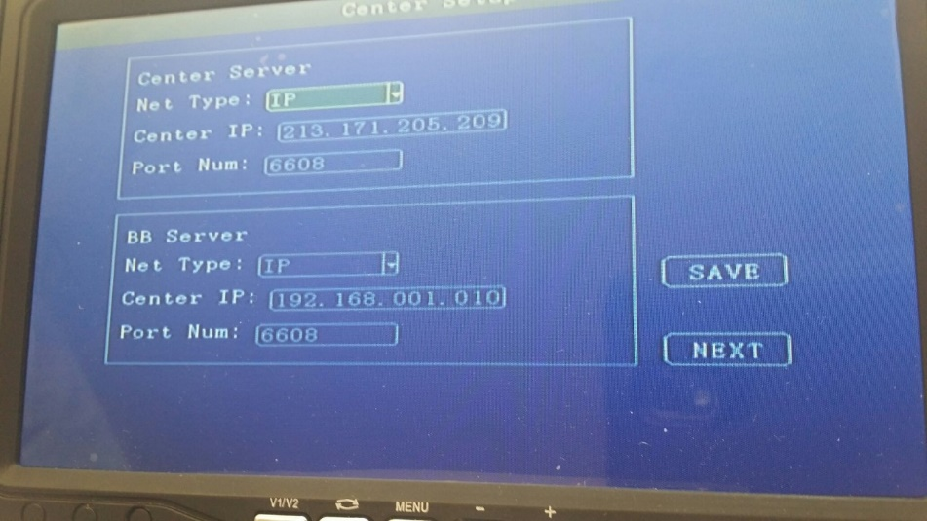

Go to 3g/4g settings
Confirm the settings below.
Net type: WCDMA
Auth mode: CHAP
Sim APN: m2mintelligence.com
Centre No: *99#
Remove all other settings
Then click SAVE.
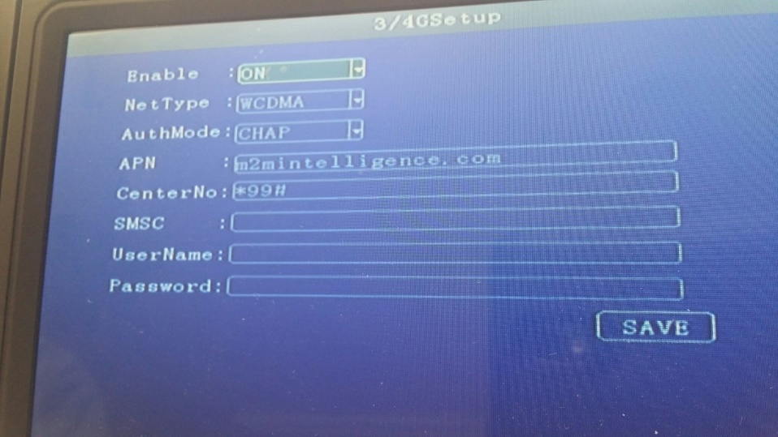
Remove power and reconnect power on DVR to apply the settings.

