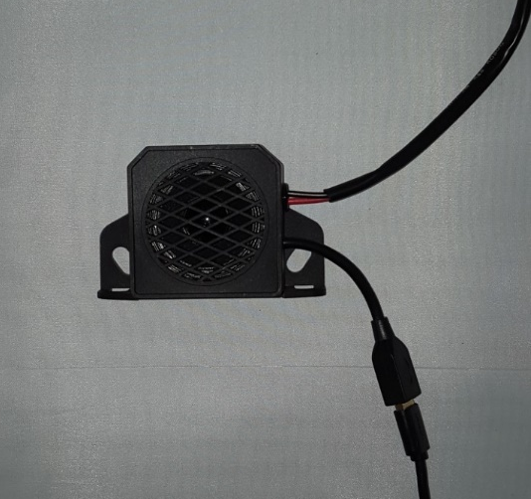
How to programme ‘Neat-sound programmable alarm’.

- Connect the alarm to a desktop using a USB cable (highlighted area). This will show a removable disk file as highlighted below.
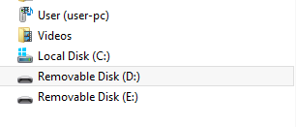

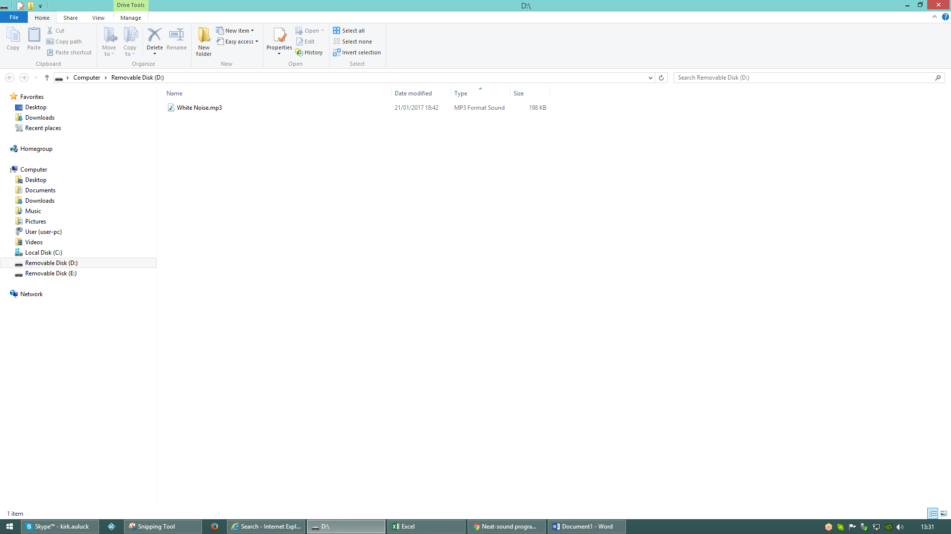
- Drop the desired sound file into the removable disk to make it the default sound. This will then be saved as the audio output of the alarm.

